1 : Faculty Contact Table
Create table faculty_contuct (faculty_id int primary key,faculty_phone_number int)
desc faculty_contuct
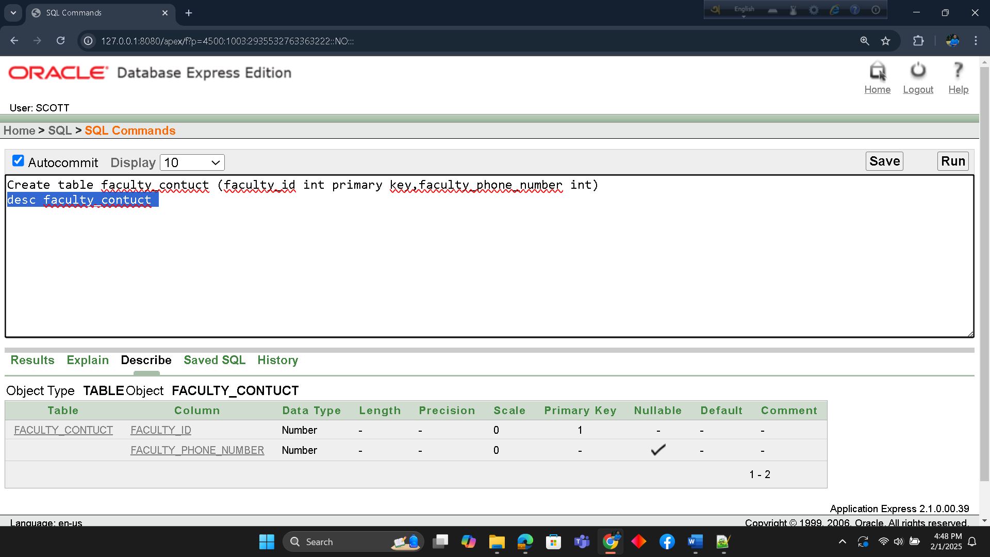
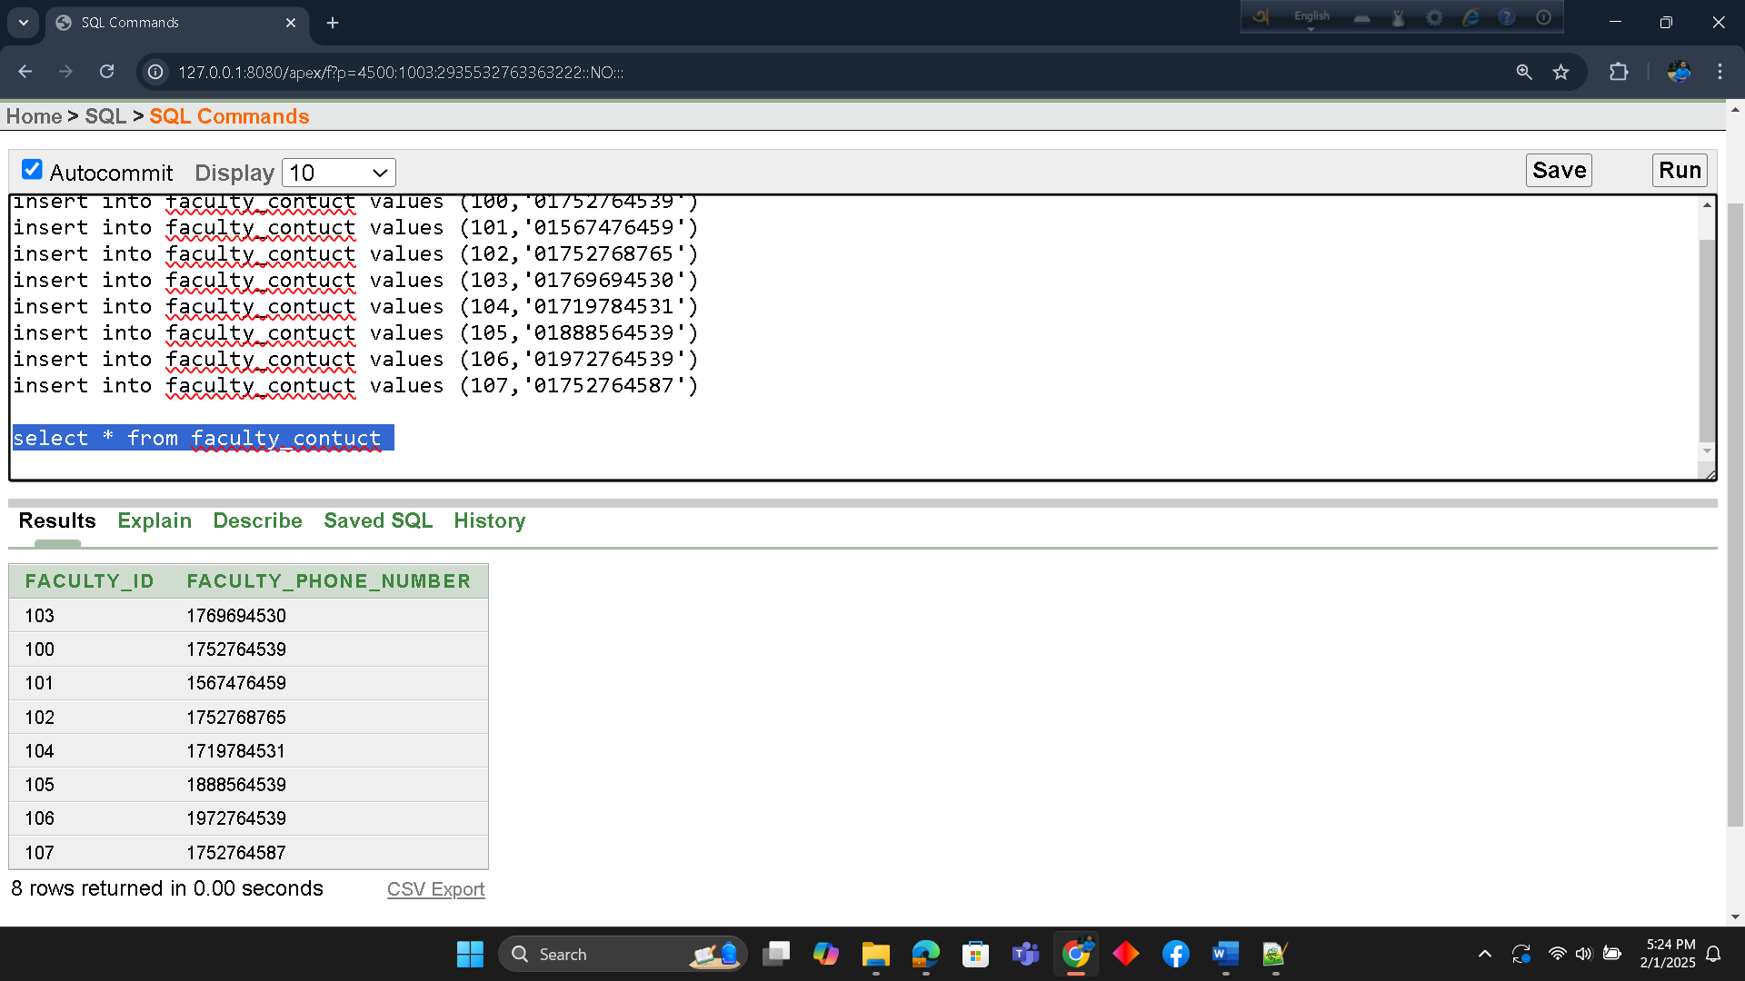

2.Student Contact Table
Create table student_contuct (student_id int primary key,student_phone int)
desc student_contuct
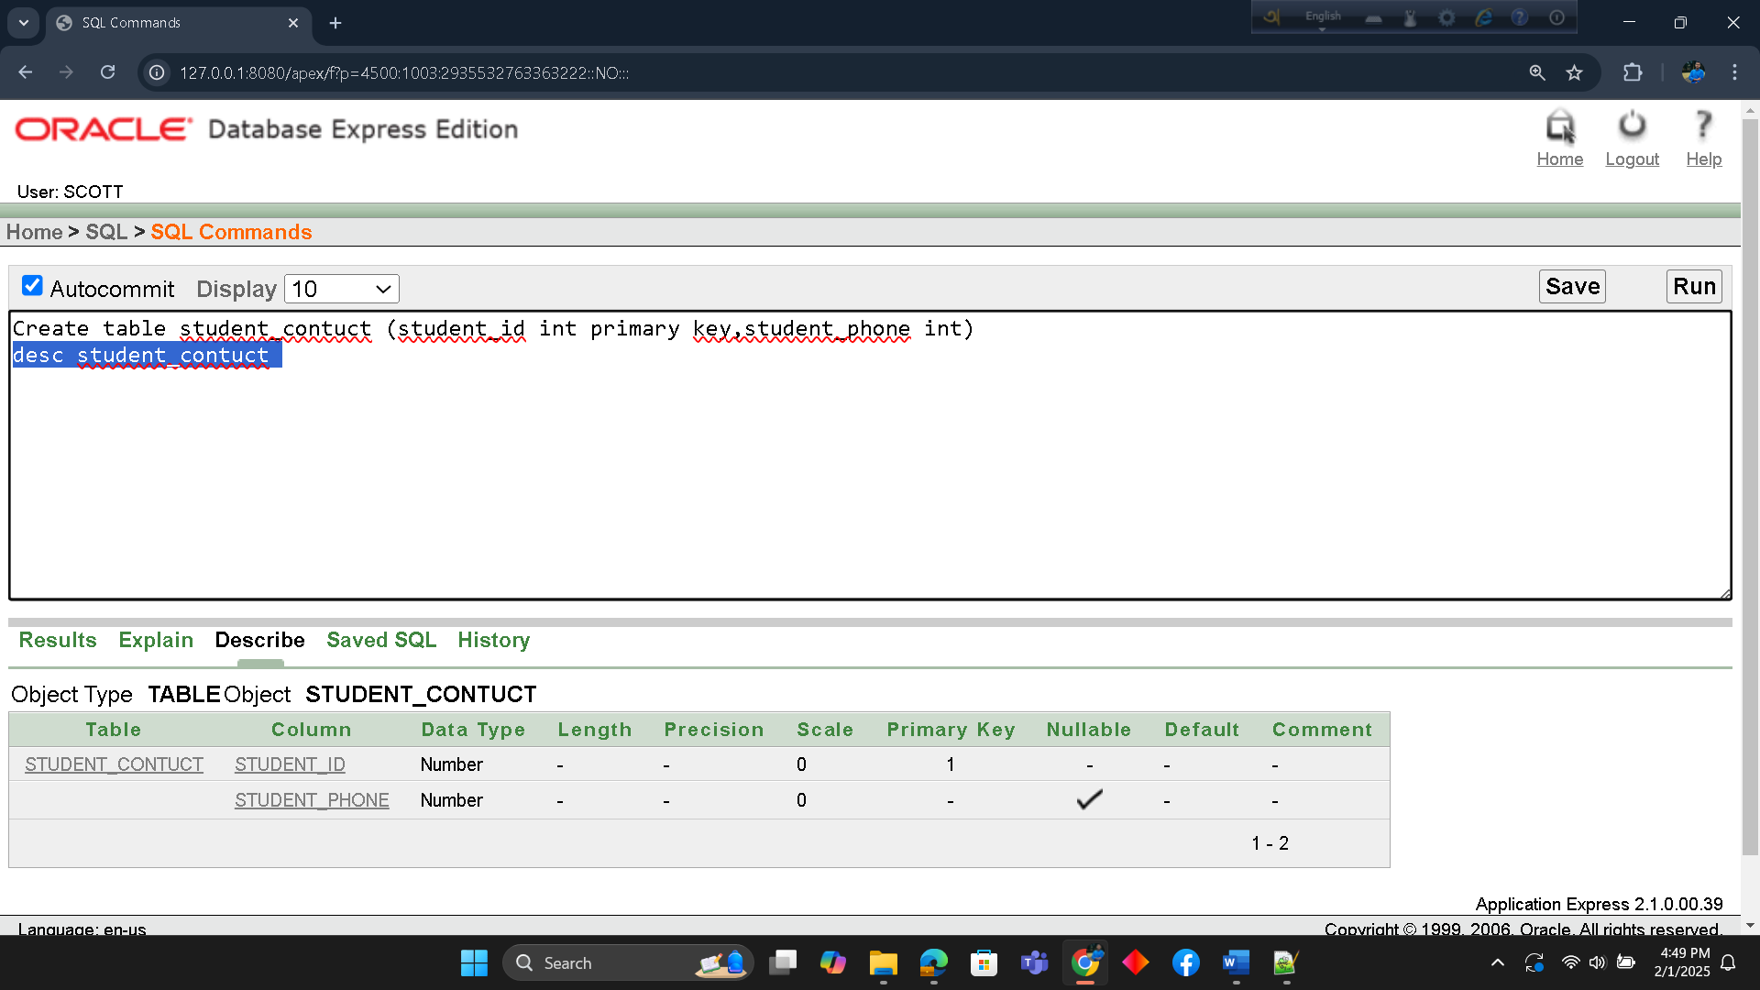
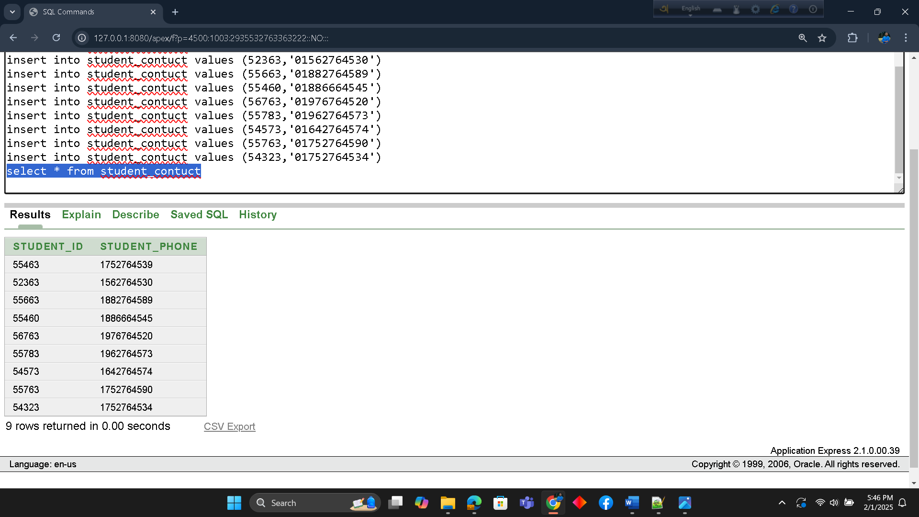
3.Student Address Table
Create table student_address (student_id int primary key,home_no varchar(100),city varchar(200))
desc student_address
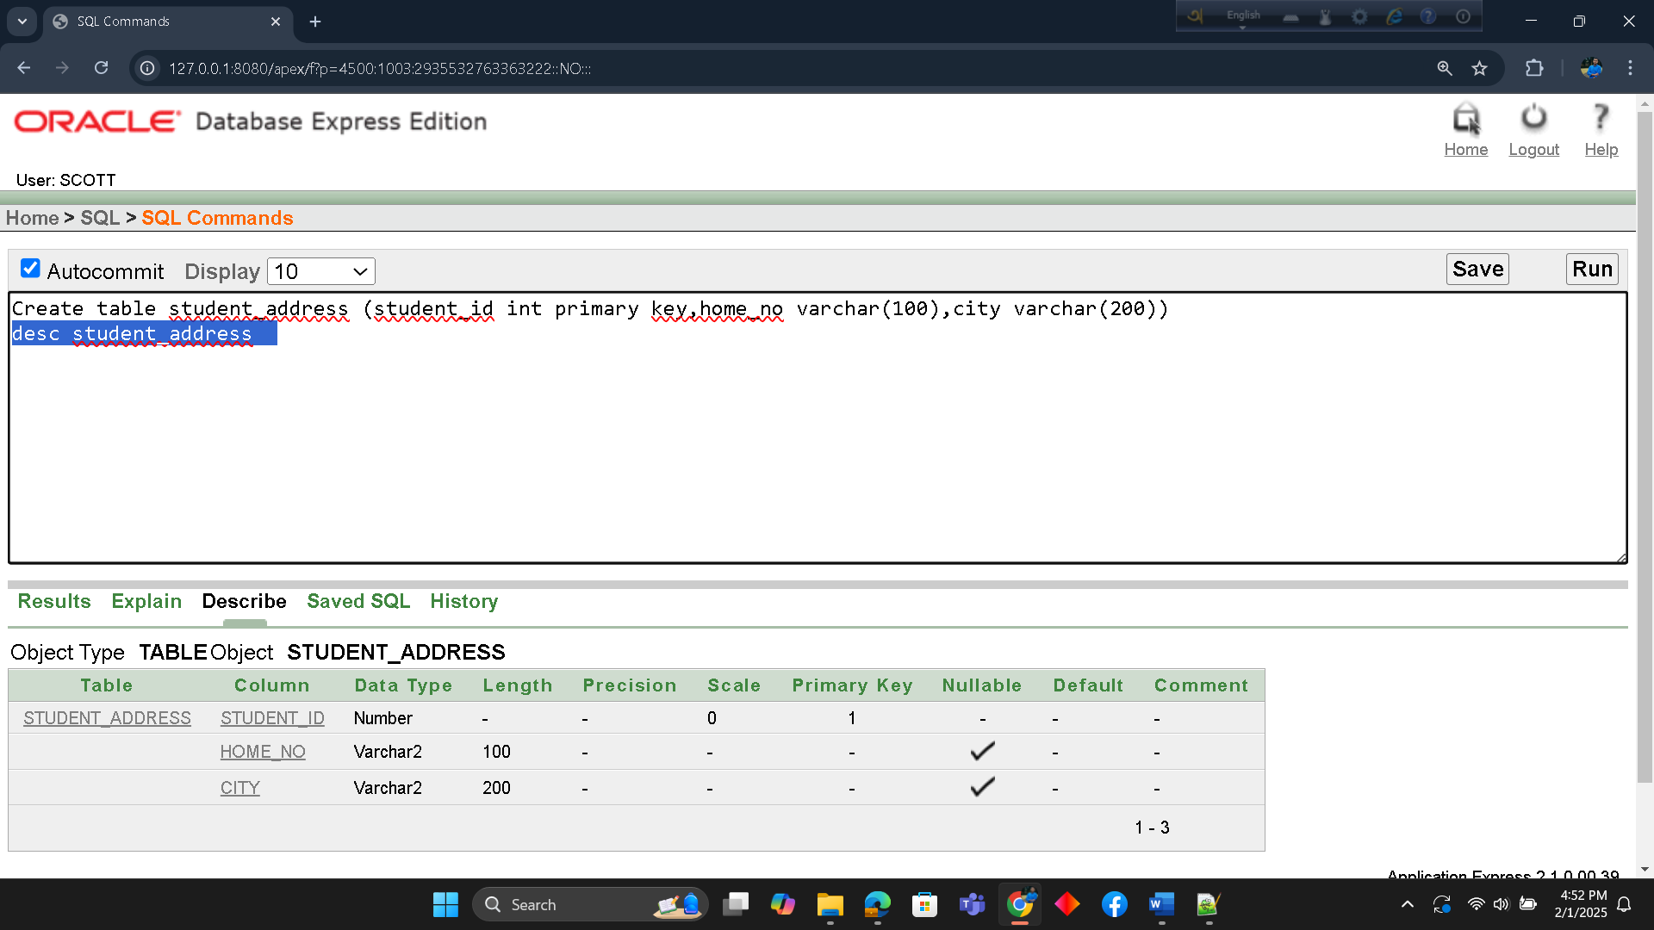

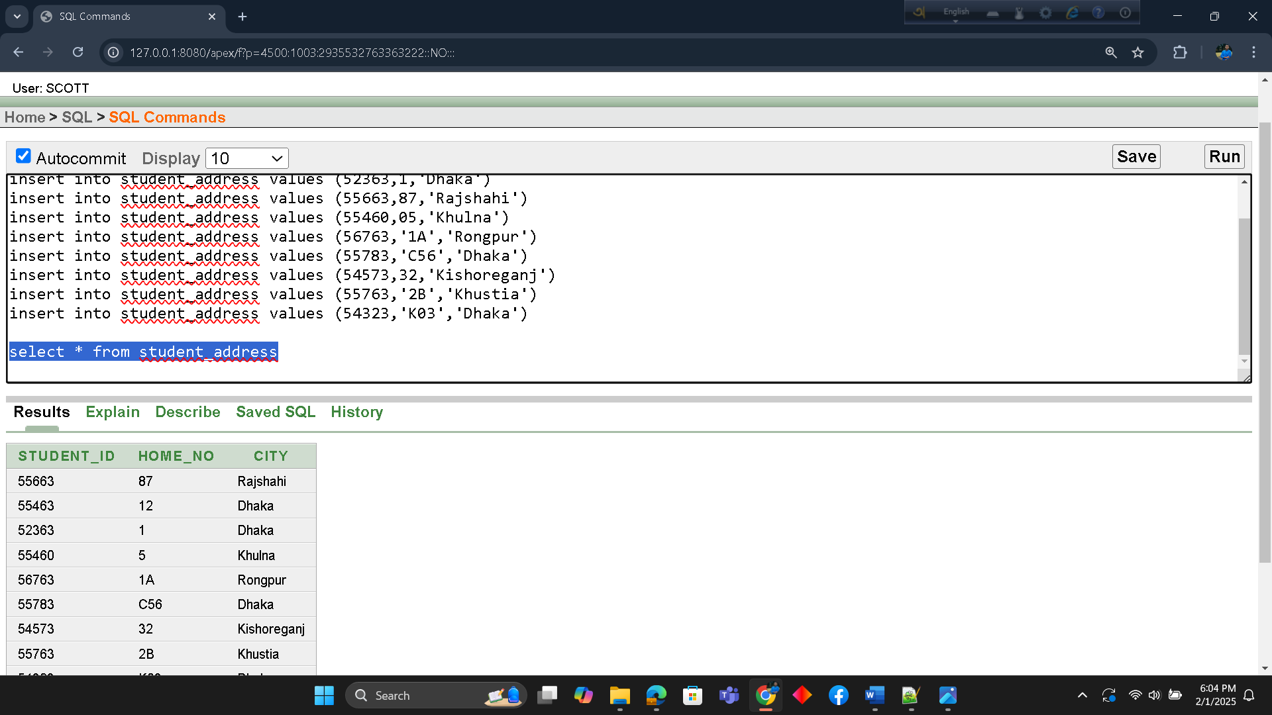

4.Student Information Table
Create table student_information
(student_id int primary key,name varchar2(100),DOB varchar2(100),Department_id number(10),faculty_id number(10))
alter table student_information add constraint t4 foreign key(faculty_id) references faculty_contuct(faculty_id)
desc student_information

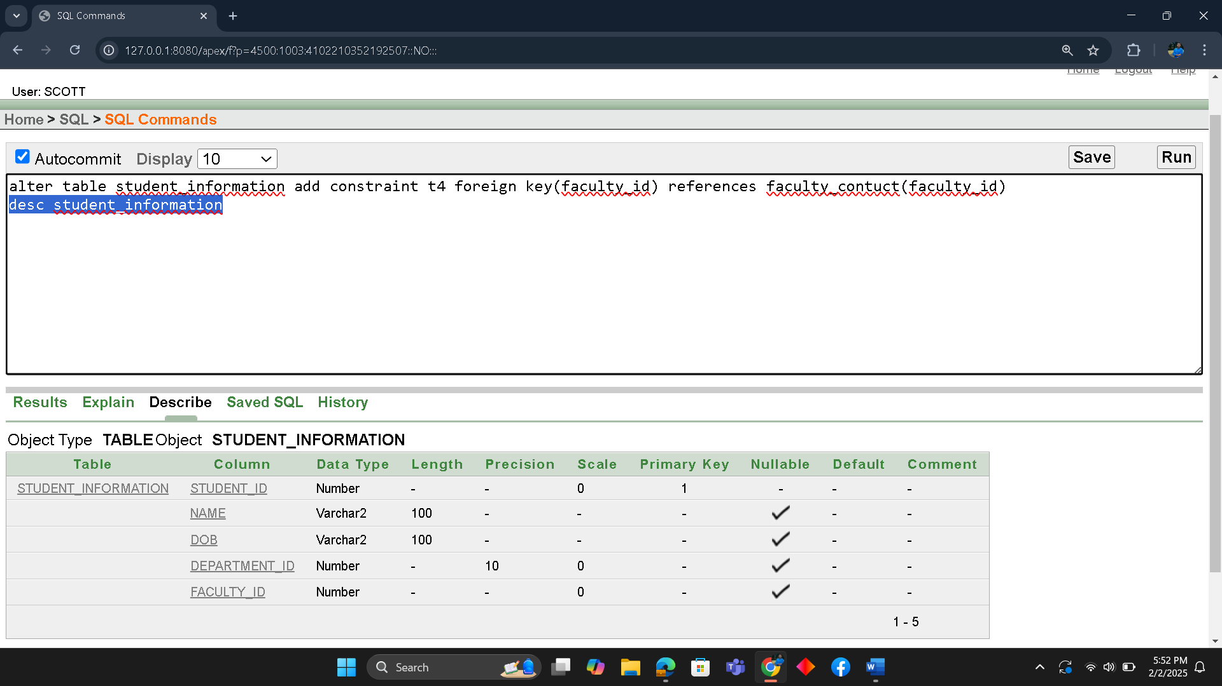
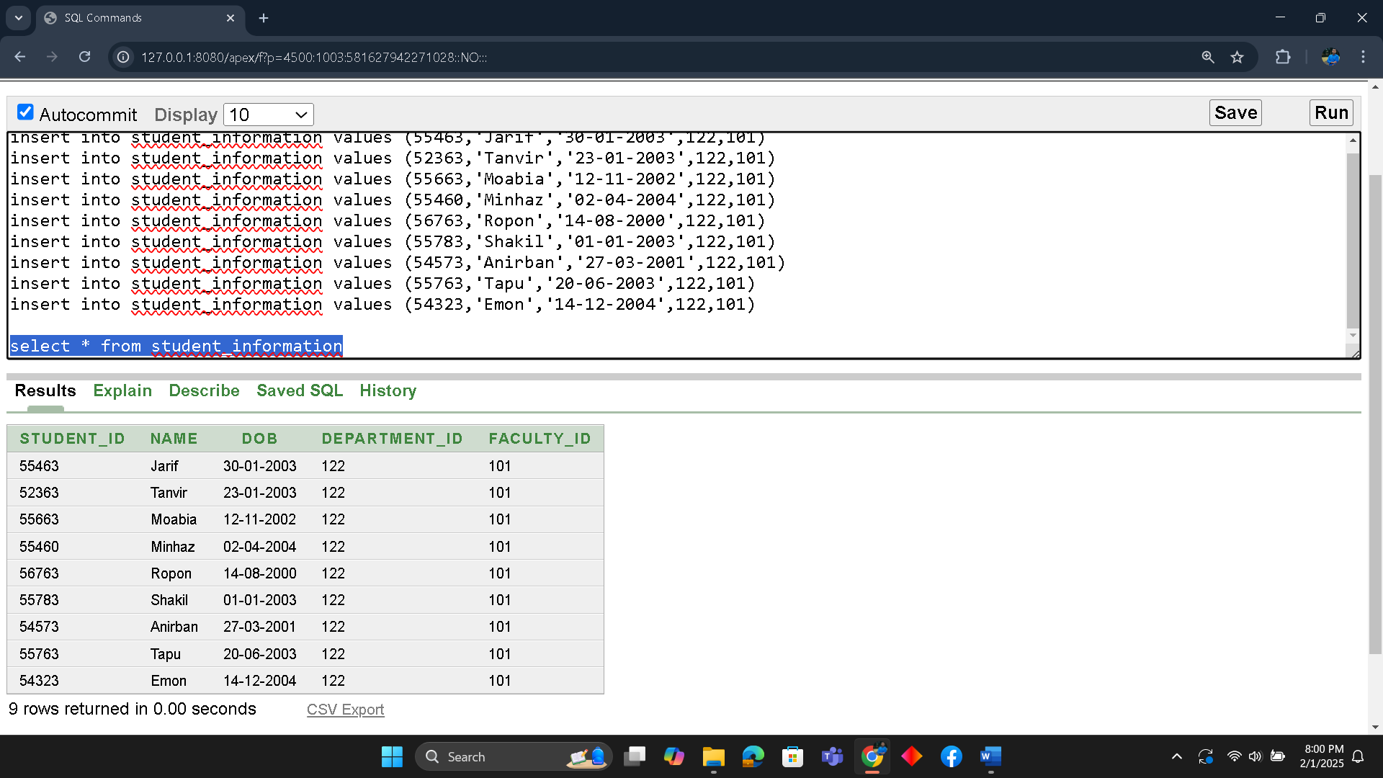

5.Faculty Information Table
Create table faculty_information
(faculty_id int primary key,faculty_name varchar2(100),email varchar2(100),Department_id number(10))
desc faculty_information
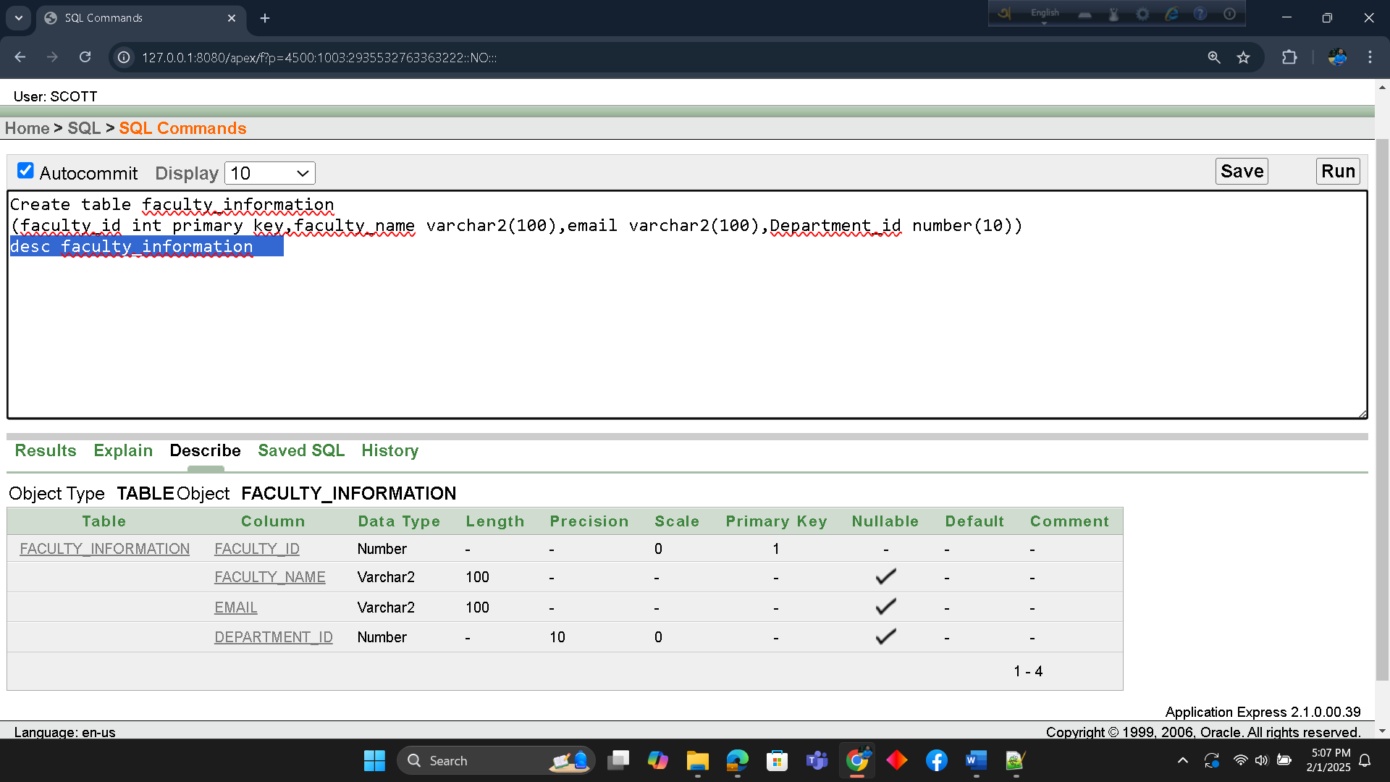
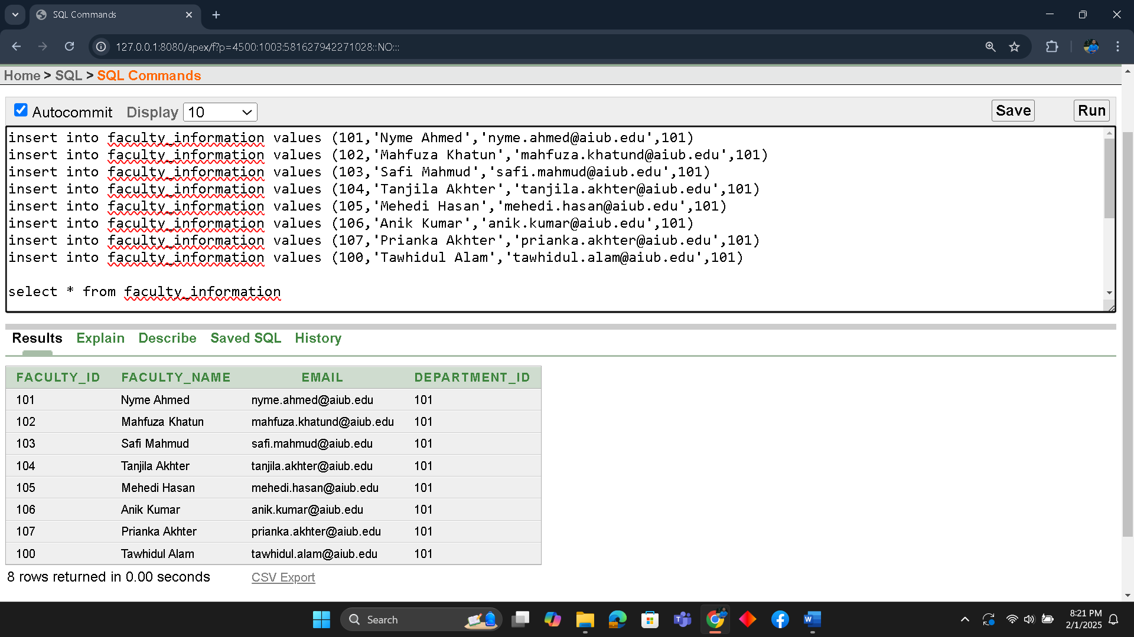
6.Student and Department Information Table
Create table student_department_information
(student_id primary key,name varchar2(100),DOB varchar2(100),department_id_number(10))
Alter table student_department_information add constraint t6 foreign key(department_id) references department_information(department_id)
desc student_department_information
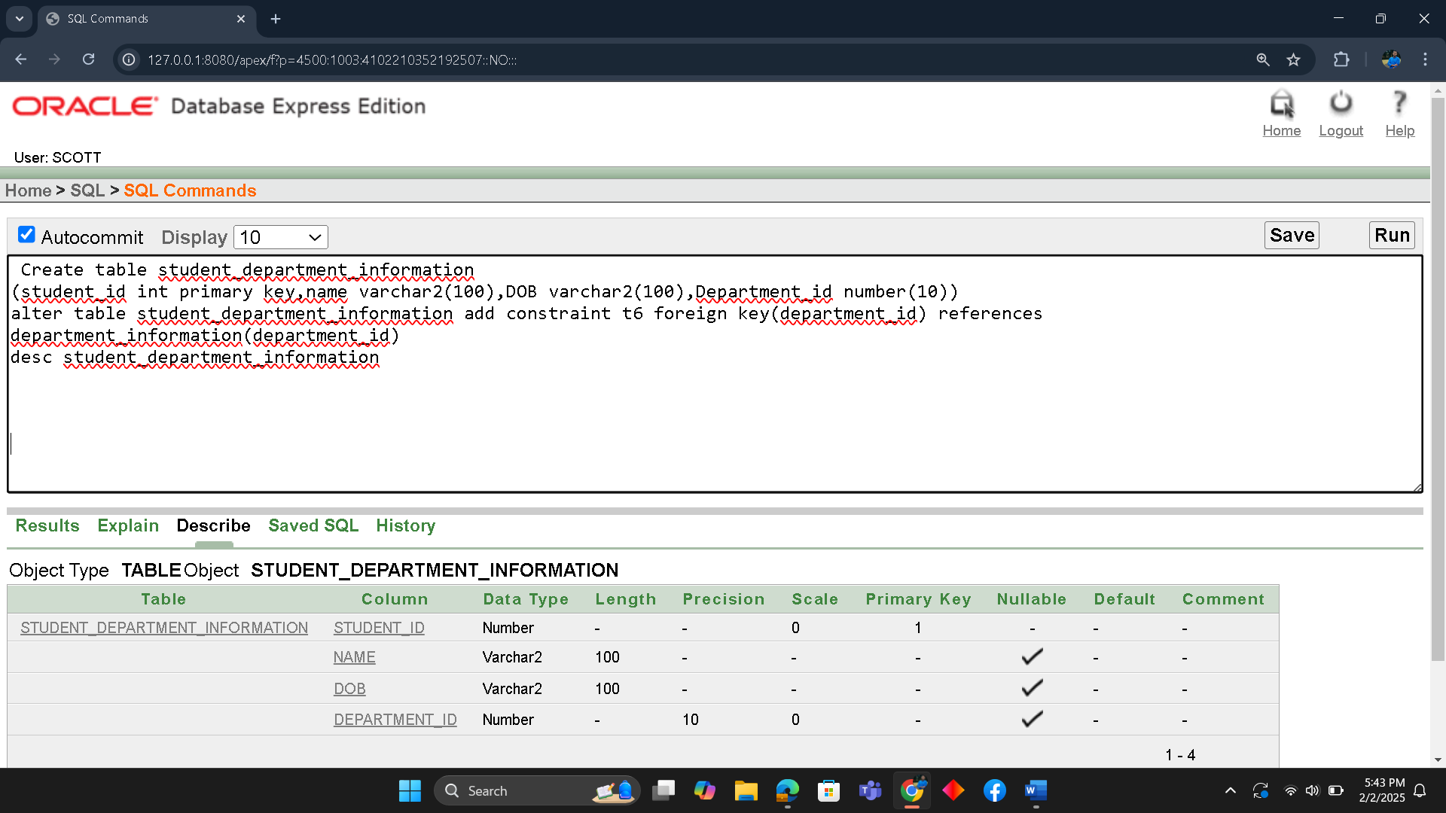
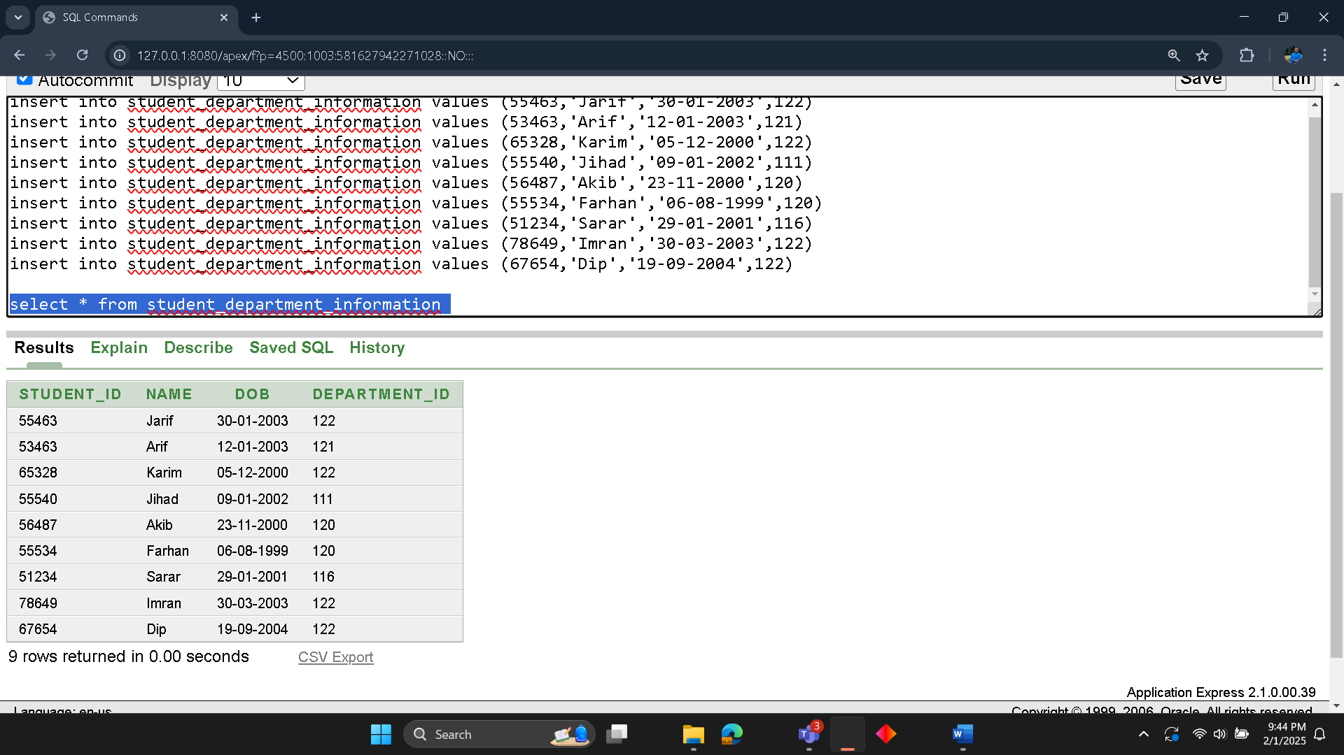

7.Department Information Table

Create table deparment_information
(deparment_id int primary key,department_name varchar2(100),faculty_id int)
alter table department_information add constraint t7 foreign key(faculty_id) references faculty_contuct(faculty_id)
desc department_information

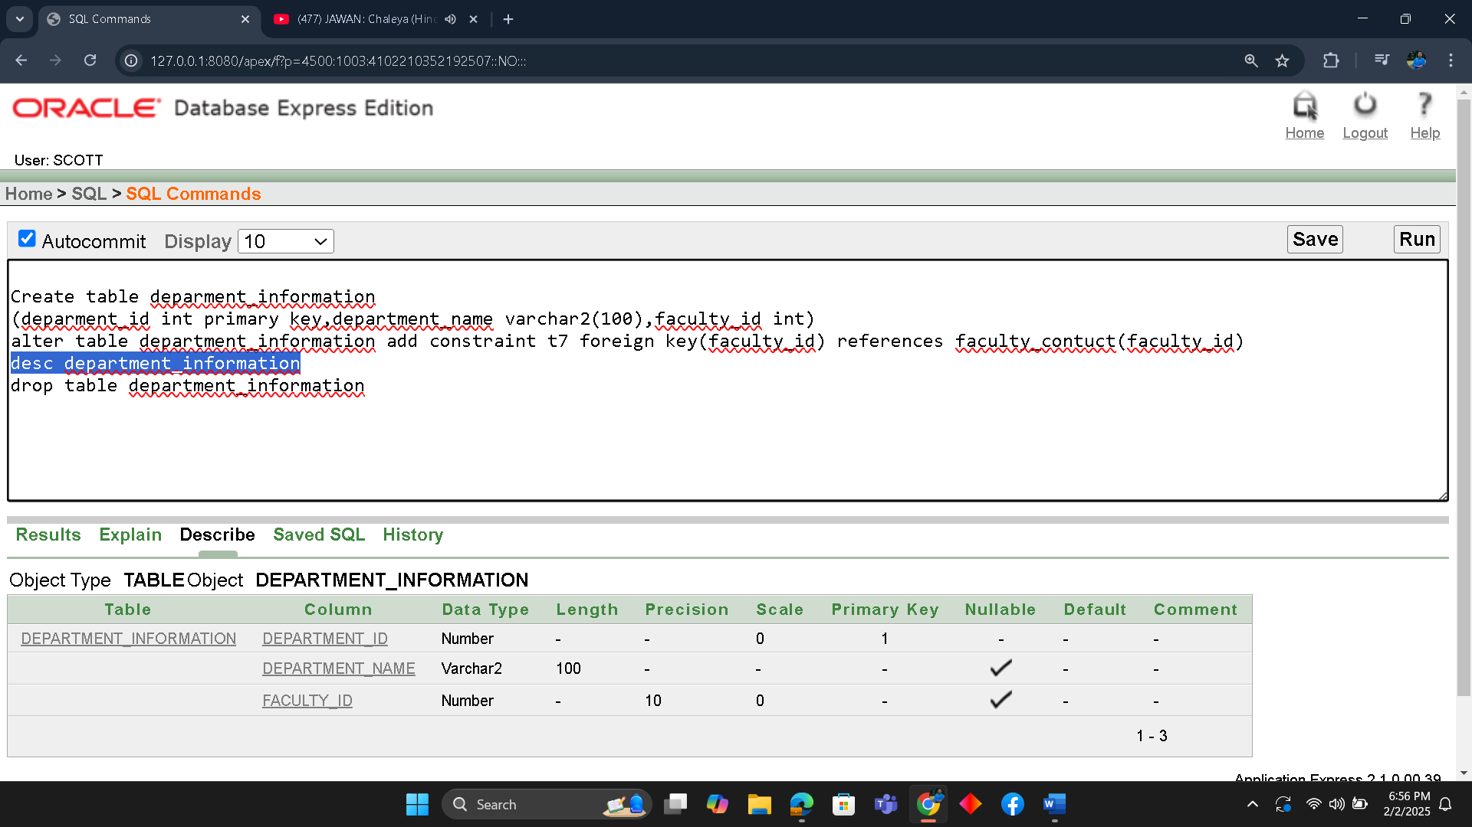

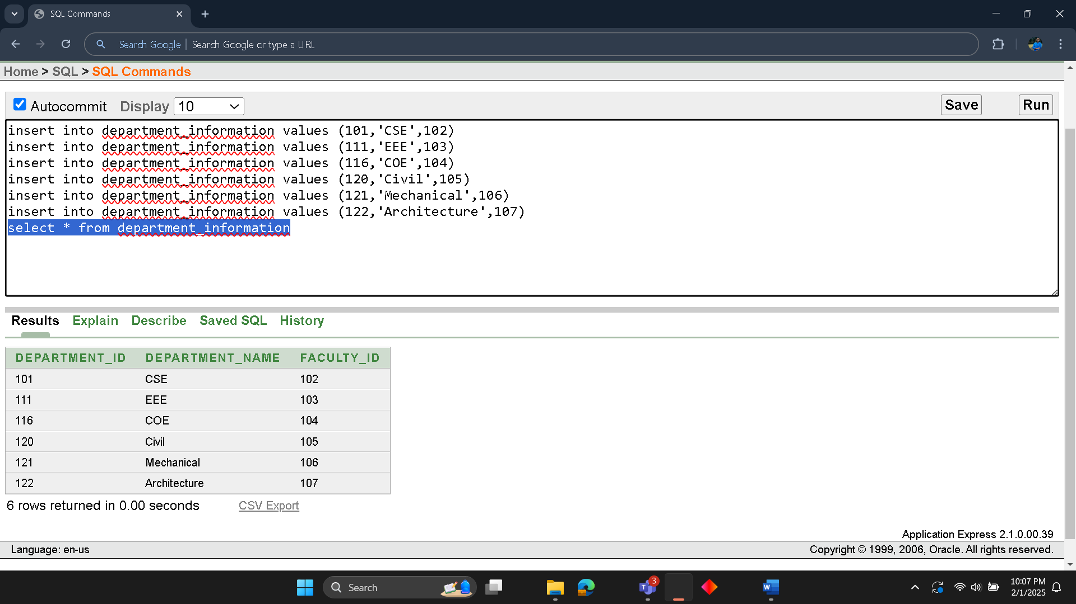

8. Course Information Table
Create table course_information
(course_id int primary key,course_name varchar2(100),course_credits number(10),department_id number(10),clasroom_id number(10),faculty_id number(10),student_id int)
alter table course_information add constraint t9 foreign key(student_id) references student_contuct(student_id)
desc course_information
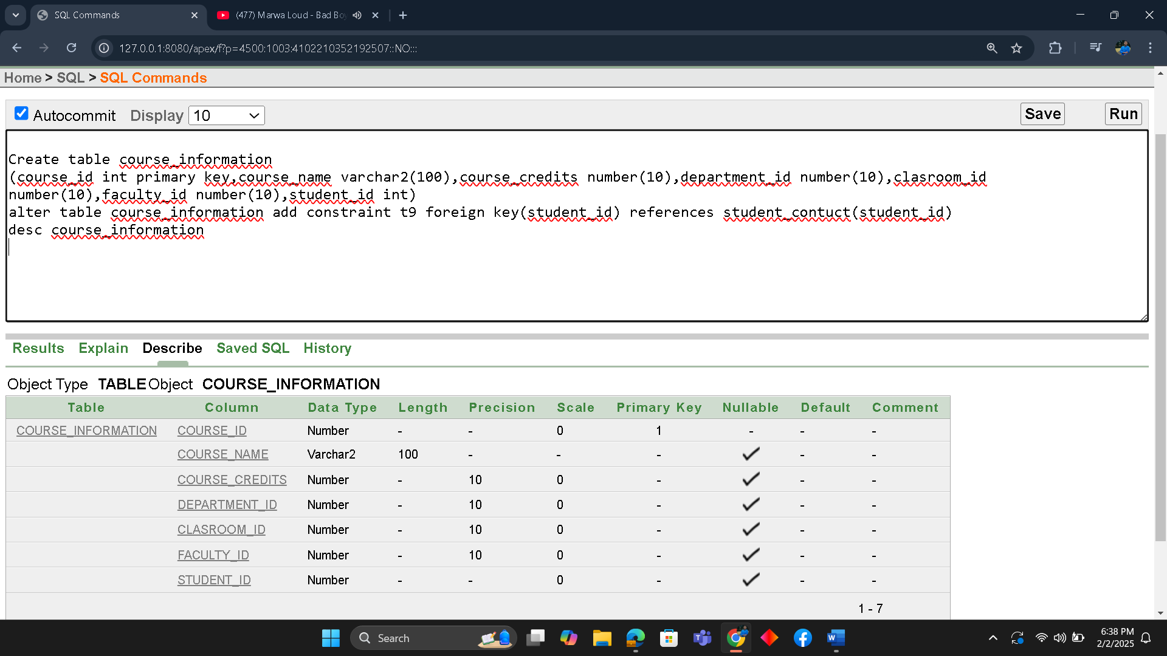

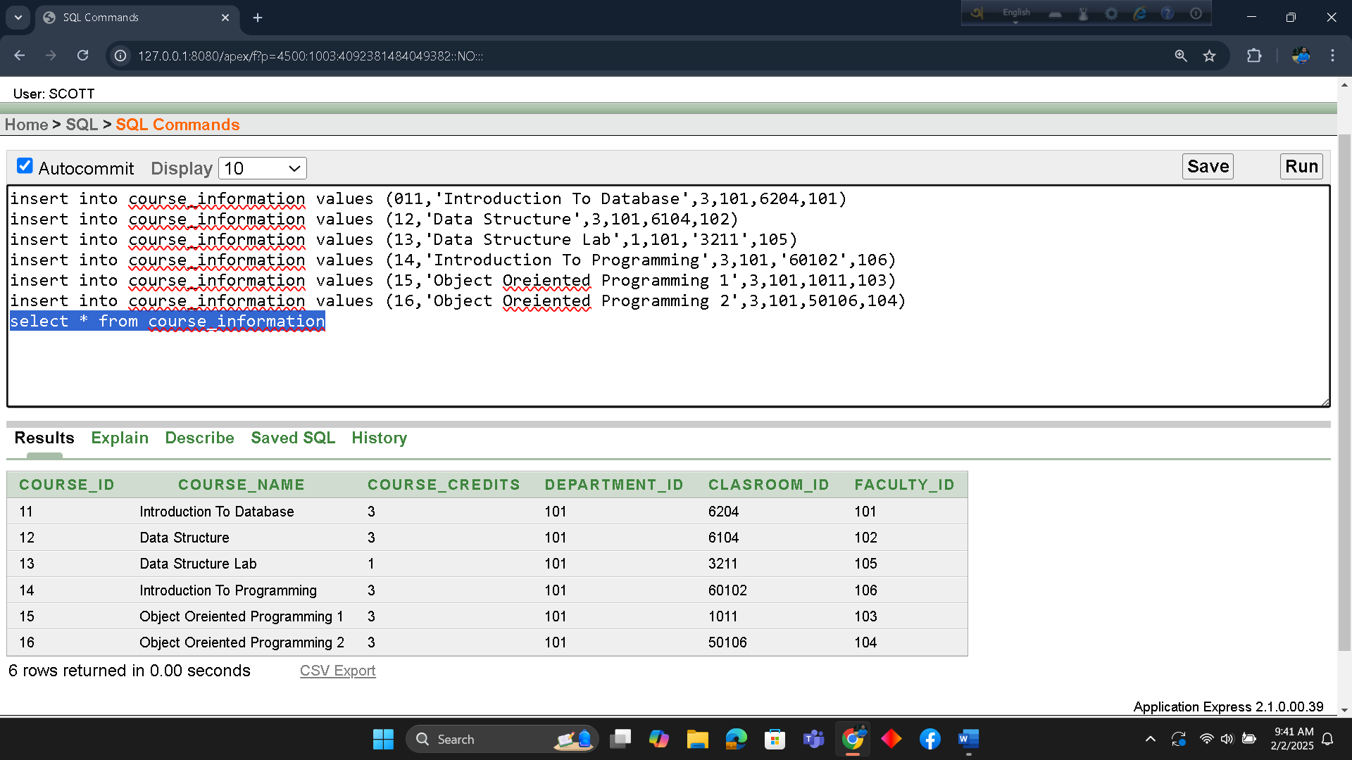

9. Classroom Information Table
Create table classroom_information
(classroom_id int primary key,building_name varchar2(100),room_number varchar2(100))
desc classroom_information
